2021 Transport Packaging Design Competition of ISTA China
Appendix 1

Competition proposition
The competition is divided into three groups. Participants can choose one proposition, or several, and only one entry can be submitted for each proposition.
After registration, the Organizing Committee will send requirements details of the proposition:
Mathematical model of the contents
Logistics requirements
Corresponding test standards to be accepted, etc

Proposition 1: Watermelon products (B to C)
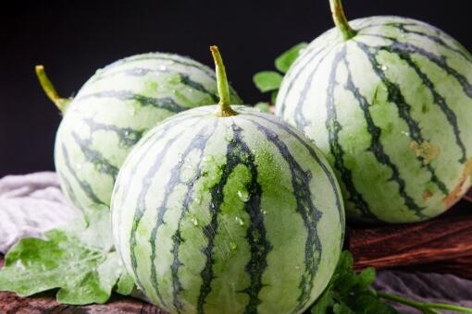
Background
Watermelon, with thin skin-thick flesh, high water content, high sweetness, good taste and many other advantages, is one of the most important fruits to quench summer heat and thirst. With the rapid development of e-commerce, watermelon has become one of the main fruits for online consumption. Although most of the packages are single, due to their thin skin and brittle quality, the goods are seriously damaged in the process of transportation and express delivery. While causing economic losses, it also reduces customer satisfaction and has a negative impact on brand image.

Proposition 2: Fresh-stewed cubilose products (B to C)
Background
With the development of the Internet economy, e-commerce and the rise of the C2M model, the fresh-stewed cubilose express delivery business has emerged in China, which is served in glass and delivered by cold chain express. This makes the Courier service industry faces a huge challenge. The glass container itself has the characteristics of fragile and so on. A large number of goods damage occurs directly to consumers, which makes consumers reduce their confidence in the brand and product quality.

Proposition 3: Tea set products (B to C)
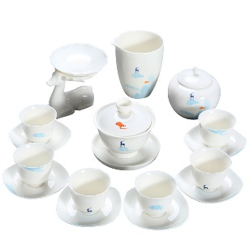
Background
Tea sets are the most important carrier in the long history of tea culture. Whether it is for personal use or as a gift, Chinese people always choose tea sets as their first choice. However, as a porcelain product, whether in express training or in bulk logistics, the fragile texture of the product itself is prone to breakage, which is a headache for merchants. While causing economic losses, it also reduces customer satisfaction and has a negative impact on brand image.

Design requirements
Material: The selection of packaging materials and auxiliary materials is not limited, and the price should be given.
Technology: The designed structure must be able to be produced using at least semi-automated equipment currently available on the market, avoiding the use of labor as much as possible.
Use: The designed package must also meet the logistics conditions provided by the Organizing Committee after registration. And it requires convenient and efficient operation and can be applied to any link such as production, transportation, loading and unloading.
Cost: It is necessary to evaluate the overall cost by combining the scheme with the selected materials.
Test: The structure is stable and the protection capability is excellent. It is required to pass the ISTA designated tests and submit the test report.
Experience: A good user experience should be satisfied. Peer evaluation will be provided by invited audience. Works do not need to involve graphic design, do not do brand design.
Brand value: packaging design should meet the need to enhance the brand value of goods, e-commerce platforms and Courier services.
Innovation and creation: innovative elements in creativity, materials, processing, structure and drawing.

Proposed Partner

Participating Contestant
